MongoDB Project about a file explorer/searcher

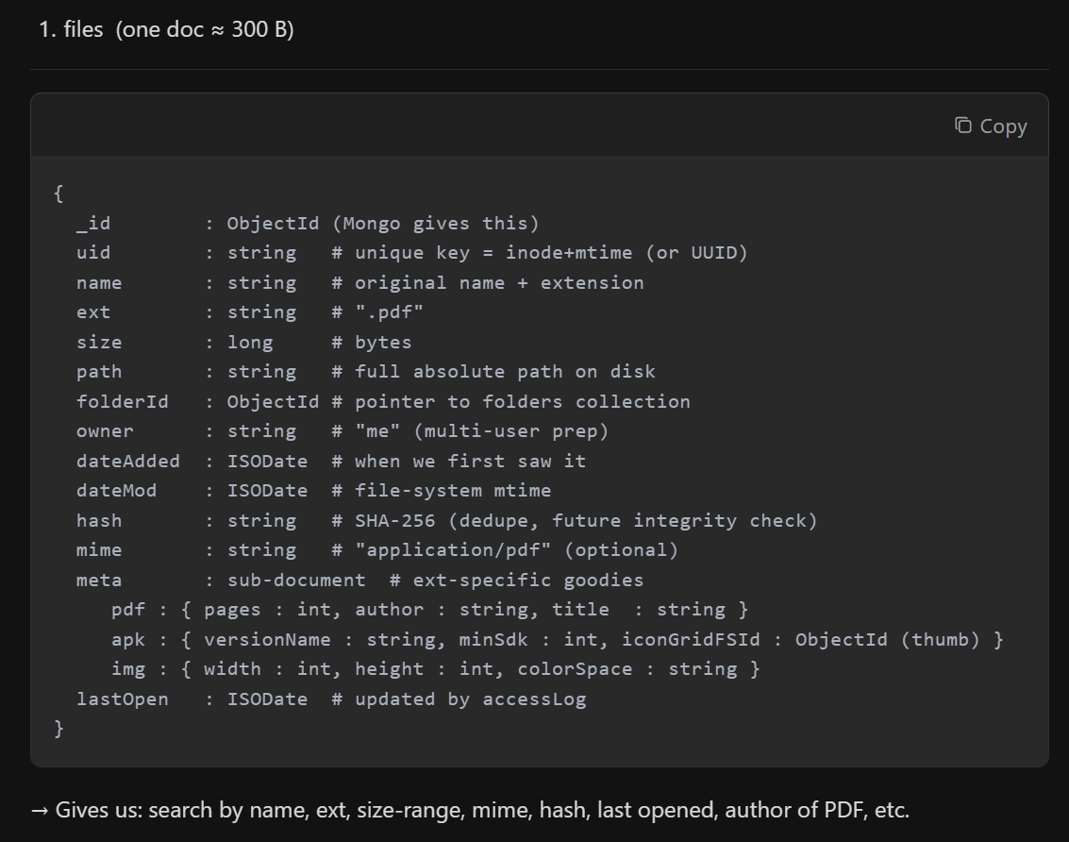
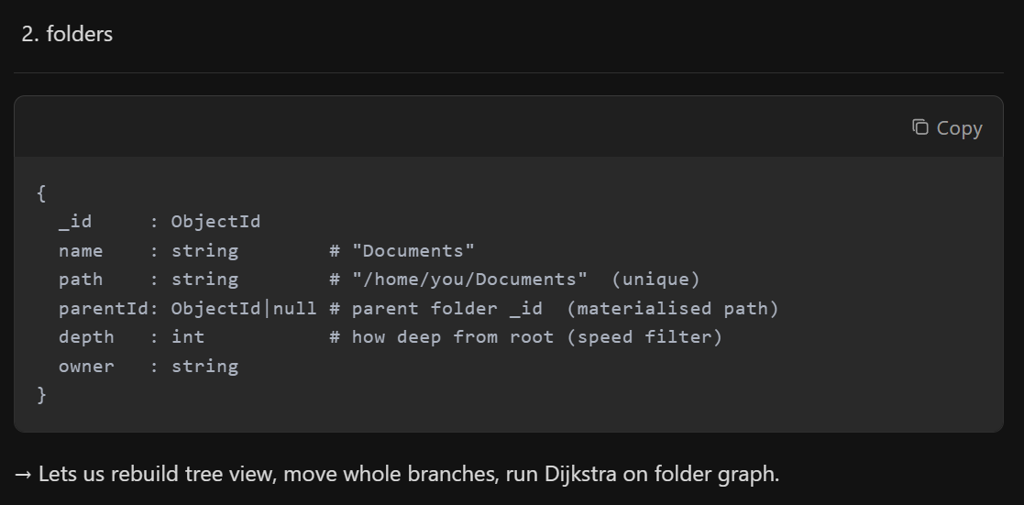
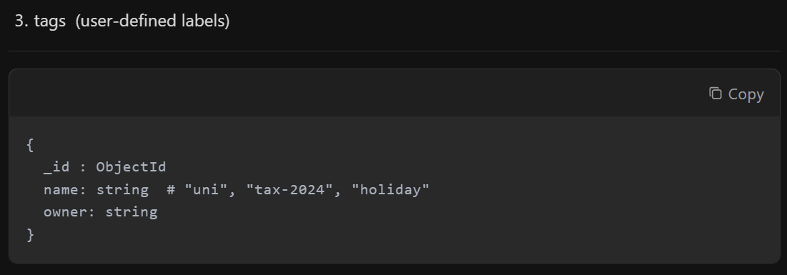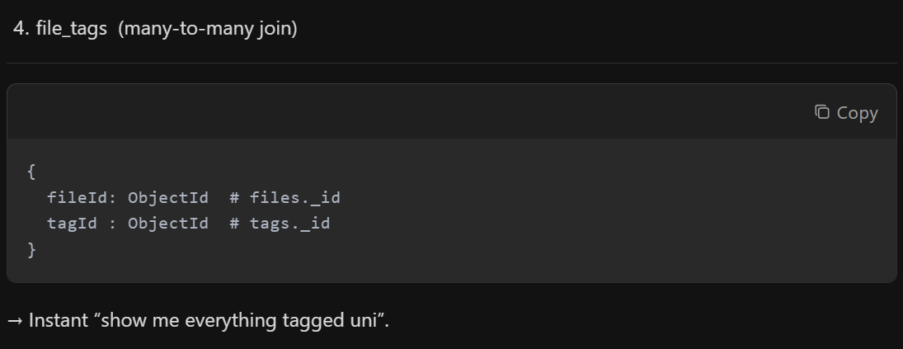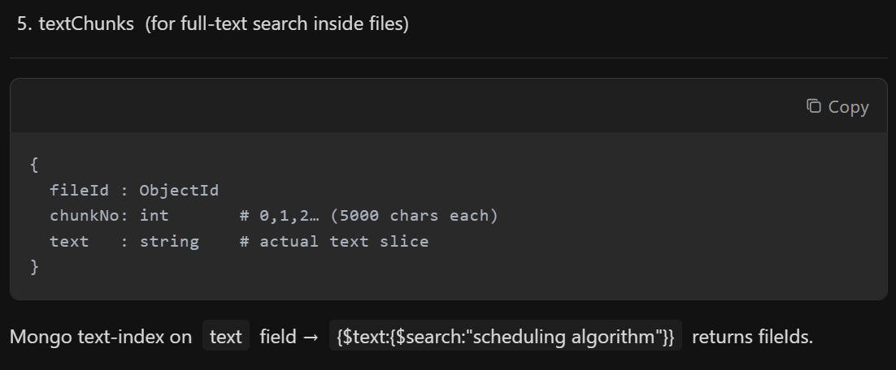
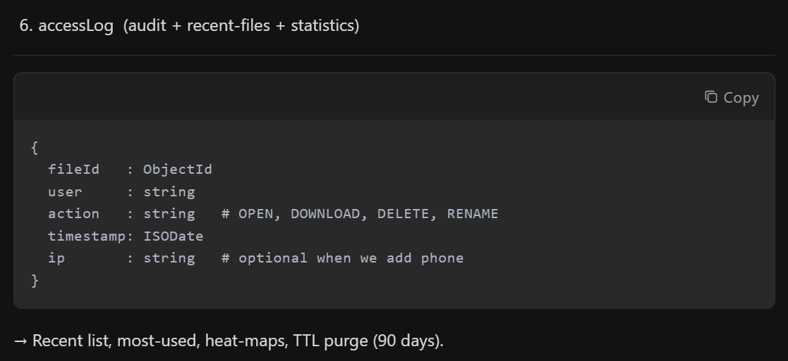
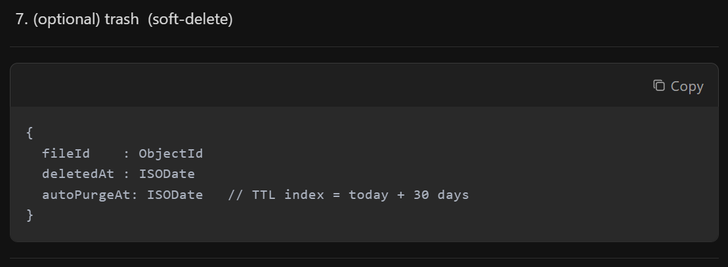

- files (one doc ≈ 300 B)
{
_id : ObjectId (Mongo gives this)
uid : string # unique key = inode+mtime (or UUID)
name : string # original name + extension
ext : string # ".pdf"
size : long # bytes
path : string # full absolute path on disk
folderId : ObjectId # pointer to folders collection
owner : string # "me" (multi-user prep)
dateAdded : ISODate # when we first saw it
dateMod : ISODate # file-system mtime
hash : string # SHA-256 (dedupe, future integrity check)
mime : string # "application/pdf" (optional)
meta : sub-document # ext-specific goodies
pdf : { pages : int, author : string, title : string }
apk : { versionName : string, minSdk : int, iconGridFSId : ObjectId (thumb) }
img : { width : int, height : int, colorSpace : string }
lastOpen : ISODate # updated by accessLog
}
- folders
{
_id : ObjectId
name : string # "Documents"
path : string # "/home/you/Documents" (unique)
parentId: ObjectId|null # parent folder _id (materialised path)
depth : int # how deep from root (speed filter)
owner : string
}
- tags (user-defined labels)
{
_id : ObjectId
name: string # "uni", "tax-2024", "holiday"
owner: string
}
- file_tags (many-to-many join)
{
fileId: ObjectId # files._id
tagId : ObjectId # tags._id
}
- textChunks (for full-text search inside files)
{
fileId : ObjectId
chunkNo: int # 0,1,2… (5000 chars each)
text : string # actual text slice
}
- accessLog (audit + recent-files + statistics)
{
fileId : ObjectId
user : string
action : string # OPEN, DOWNLOAD, DELETE, RENAME
timestamp: ISODate
ip : string # optional when we add phone
}
- (optional) trash (soft-delete)
{
fileId : ObjectId
deletedAt : ISODate
autoPurgeAt: ISODate // TTL index = today + 30 days
}

